General response generation flow:

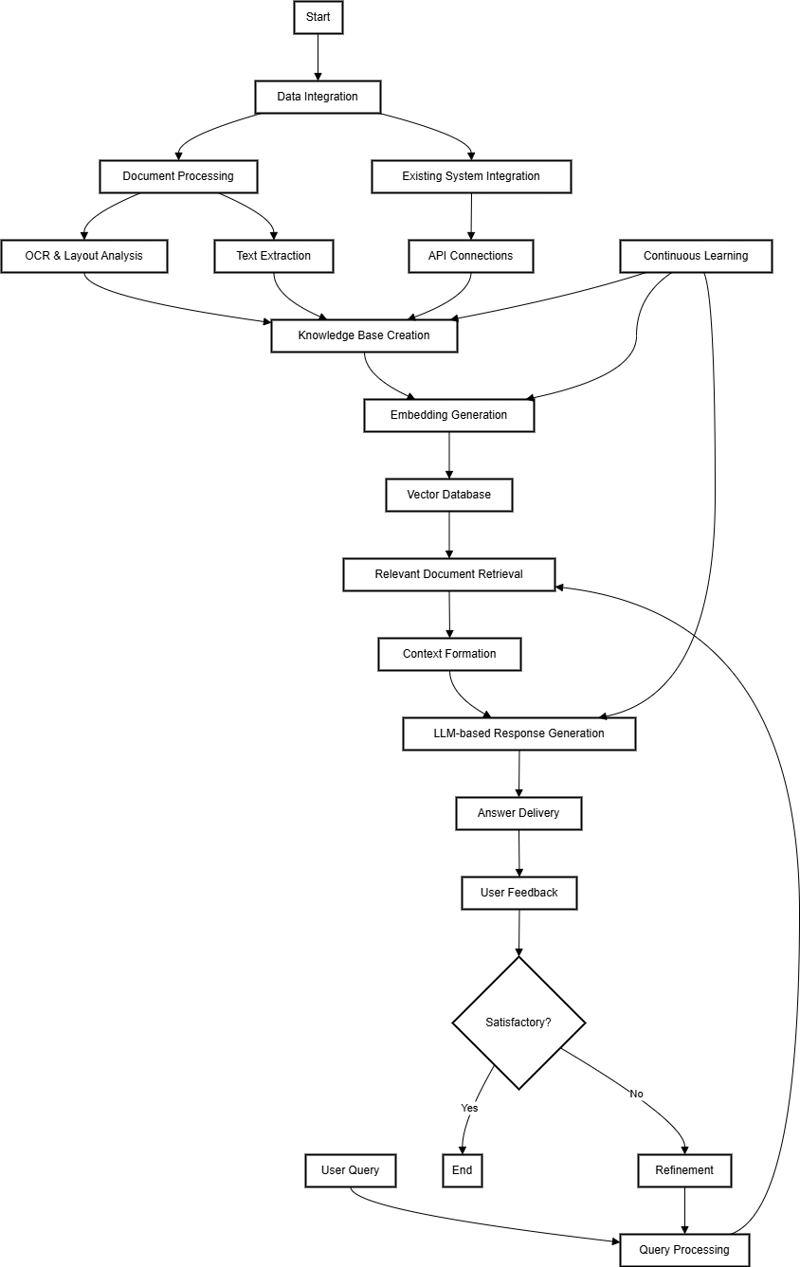  
  
# Advanced RAG-based Retail Business Assistant: Transforming Data into Strategic Insights

## Executive Summary

The Advanced RAG-based Retail Business Assistant is a cutting-edge AI solution designed to revolutionize decision-making and operations for retail businesses. By leveraging Retrieval-Augmented Generation (RAG) technology, this system seamlessly integrates with existing business management platforms, transforming raw data from various sources into actionable insights. The assistant empowers managers and executives to make informed decisions quickly across multiple business functions, improving operational efficiency, customer satisfaction, and overall profitability.

## Key Features

1. **Comprehensive Data Integration**:

- Connects with various data sources and file types (databases, PDFs, Excel sheets, Word documents, images)

- Extracts information from handwritten notes, complex document layouts, and legacy systems

- Easily integrates with existing business systems like PetPooja, ERP systems, CRM platforms, and financial software

2. **Intelligent Information Retrieval and Analysis**:

- Analyzes the relevance and reliability of available data for specific queries

- Provides answers only when confident in the available information

- Offers trend analysis and predictive insights across various business domains

3. **Natural Language Interface**:

- Allows users to ask complex business questions in plain language

- Translates multifaceted data into easy-to-understand responses

- Supports multi-lingual queries and responses for global operations

4. **Context-Aware Responses**:

- Considers the source, format, and context of information when generating answers

- Maintains awareness of business rules, industry regulations, and company policies

5. **Adaptive Learning and Customization**:

- Improves performance over time as it processes more company-specific data

- Can be fine-tuned to understand industry-specific terminology and business needs

- Allows for custom module development to address unique business requirements

## Integration with Existing Systems

The Advanced RAG-based Retail Business Assistant is designed for seamless integration with popular business management systems. Here's how it enhances these existing systems:

1. **Holistic Data Utilization**:

- Automatically pulls relevant data from various business systems (e.g., POS, ERP, CRM, HR systems)

- Combines structured data with information from unstructured sources (e.g., customer feedback, market reports)

2. **Cross-functional Analysis**:

- Augments built-in reports with AI-driven insights that span multiple business functions

- Provides a layer of predictive analytics and scenario planning capabilities

3. **User-Friendly Interface**:

- Accessible through a simple chat interface or integrated directly into existing dashboards

- Allows users to ask complex, cross-functional questions without navigating multiple systems or reports

4. **Real-Time Updates and Alerts**:

- Continuously syncs with all connected systems to ensure responses are based on the most current data

- Proactively alerts users to significant changes, trends, or anomalies across business operations

## Use Cases

1. **Inventory and Supply Chain Optimization**:

Q: "Based on current trends and upcoming events, how should we adjust our inventory and supplier orders for the next quarter?"

A: The assistant analyzes sales data, market trends, event calendars, and supplier performance to provide comprehensive inventory and ordering recommendations.

2. **Financial Planning and Analysis**:

Q: "How would a 10% increase in marketing spend impact our profitability, considering seasonal trends and competitor activities?"

A: The system runs scenario analyses, considering historical data, market conditions, and competitive landscape to forecast the financial impact.

3. **Customer Behavior and Marketing Effectiveness**:

Q: "What customer segments are most responsive to our recent marketing campaign, and how has this affected their purchasing patterns?"

A: The assistant combines CRM data, marketing campaign results, and sales data to provide insights on customer segmentation and behavior changes.

4. **Human Resources and Staffing Optimization**:

Q: "Based on historical data and predicted foot traffic, what should our staffing levels be for each department next month?"

A: By analyzing sales data, foot traffic patterns, and labor efficiency metrics, the system offers data-driven staffing recommendations.

5. **Competitive Analysis and Market Positioning**:

Q: "How does our product mix and pricing strategy compare to our top competitors, and where are the opportunities for differentiation?"

A: The assistant analyzes market data, competitor information, and internal sales data to provide strategic insights on market positioning.

## Benefits

1. **Enhanced Decision Making**: Provides data-driven insights across all business functions for more informed strategic decisions.

2. **Operational Efficiency**: Reduces time spent on data analysis and report generation, allowing focus on strategy implementation.

3. **Cost Optimization**: Identifies areas for cost reduction and efficiency improvements across the business.

4. **Improved Customer Experience**: Enables personalized customer interactions and optimized product offerings.

5. **Agile Business Operations**: Facilitates quick responses to market changes and business challenges.

6. **Cross-functional Collaboration**: Breaks down data silos and encourages holistic business thinking.

7. **Regulatory Compliance**: Helps ensure business decisions align with industry regulations and company policies.

## Implementation and Onboarding

1. **System Setup**:

- Phased integration with existing business systems

- Minimal disruption to ongoing operations

2. **Data Integration and Security**:

- Secure import and handling of data from various sources

- Robust data governance and compliance measures

3. **User Training and Adoption**:

- Role-based training programs

- Change management support to ensure smooth adoption across the organization

4. **Ongoing Support and Evolution**:

- Regular updates to improve performance and add new features

- Dedicated support team for troubleshooting and custom development

## Conclusion

The Advanced RAG-based Retail Business Assistant represents a paradigm shift in retail business management. By seamlessly integrating with existing systems and providing AI-driven insights across all business functions, it empowers retail organizations to optimize their operations, make data-driven decisions, and stay ahead in a competitive market. This easy-to-use, comprehensive solution bridges the gap between complex business data and actionable strategies, making it an indispensable tool for modern retail management and strategic planning.

Site flow:

